Siltronic Financial Memo Student Name: Fariel Shafee

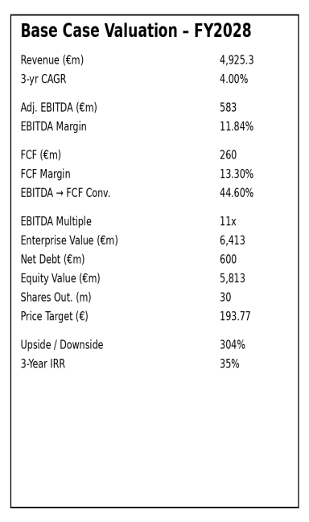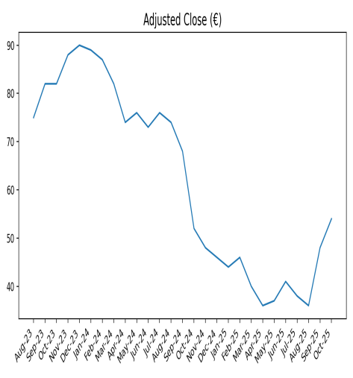

Executive Summary — Siltronic AG
Siltronic represents an opportunity to acquire a high-quality, strategically critical semiconductor materials business at depressed mid-cycle earnings.
Our Base case assumes FY2028 revenue of ~€4.9bn, EBITDA margins of ~12%, and an 11× EV/EBITDA multiple, consistent with historical mid-cycle trading. This equates to a ~35% 3-year IRR. The Base case relies on utilization normalization and steady demand from logic and memory customers.
Siltronic exhibits favorable asymmetry, with ~2.7× upside-to-downside in the Base case. Downside is well-defined and cyclical in nature, while upside benefits from structural semiconductor content growth and long-term supply constraints.
We believe this setup offers returns skewed meaningfully to the upside for investors.

Business Overview — Siltronic AG
Siltronic AG is a leading global manufacturer of ultra-pure silicon wafers, a mission-critical input for semiconductor fabrication across logic, memory, and power devices. The company serves all major global semiconductor manufacturers, supplying 200mm and 300mm wafers under long-term contracts with high switching costs and stringent qualification requirements.
Silicon wafers typically represent <2% of total chip manufacturing cost, yet directly impact yield, performance, and reliability—making supplier reliability and quality paramount. As a result, Siltronic benefits from multi-year customer relationships, high retention, and limited price-based competition.
Siltronic is currently emerging from a cyclical downturn marked by inventory correction and utilization pressure, which has disproportionately impacted near-term earnings and investor sentiment.

Investment Thesis

1. Siltronic provides a indispensable catch in the semiconductor value chain
Siltronic occupies a non-substitutable position in semiconductor manufacturing. Wafer quality directly affects chip yields, making customers unwilling to risk switching for marginal savings.
Once qualified, suppliers are deeply embedded in customer production flows, resulting in high retention and long contract duration. This dynamic creates earnings durability through the cycle and supports normalized margins when utilization recovers.

2. Cyclical reset has obscured normalized earnings power
Siltronic’s share price reflects near-trough utilization and margin assumptions, despite the company having already absorbed the bulk of its capacity expansion capex.
Our Base case assumes FY2028 revenue of ~€4.9bn and EBITDA margins of ~12%, well below prior cycle peaks but consistent with normalized mid-cycle conditions. At an 11× EBITDA multiple, this yields a ~€194 price target and ~35% IRR.
3. Capex peak behind us; free cash flow inflection ahead
Siltronic has completed its most intensive phase of capacity expansion, positioning the business for improving capital efficiency as volumes recover. As utilization normalizes:
4. Industry structure and consolidation support valuation floor
The silicon wafer market is highly consolidated, capital-intensive, and supply disciplined.
Comparable transactions and historical trading ranges suggest that 7× EBITDA represents a trough valuation, while normalized environments support double-digit multiples—providing a natural valuation floor during periods of stress.
Siltronic offers exposure to long-term semiconductor growth through a capital-disciplined, mission-critical supplier, currently valued near cyclical trough assumptions. With downside anchored by conservative multiples and upside driven by utilization normalization, the investment presents compelling asymmetric return potential.

Siltronic AG — Management Team & Board Summary

Executive Leadership
Dr. Michael Heckmeier — Chief Executive Officer
Dr. Heckmeier has served as CEO since May 2023 and recently had his contract extended through May 2031, signaling strong board confidence. He holds a PhD in Physics and spent nearly 25 years at Merck KGaA, where he led global businesses across materials, display solutions, and new ventures before joining Siltronic. Heckmeier is responsible for overall strategic direction, global operations, and navigating Siltronic through cyclical industry dynamics.
Claudia Schmitt — Chief Financial Officer
Appointed CFO in June 2023, Schmitt’s contract was also extended through June 2031, reflecting board confidence in her stewardship of the company’s financial strategy. She joined Siltronic in 2009 and held senior finance roles prior, including Corporate VP of Controlling and Treasury. Her background includes extensive experience in controlling, planning, and financial operations from her earlier tenure at Wacker Chemie AG.
Klaus Buchwald — Chief Operating Officer
Buchwald joined as COO in June 2024 to strengthen operational execution, supply chain, and production efficiency. He brings over two decades of semiconductor operations experience, including senior roles at Infineon Technologies AG and Rohde & Schwarz. His appointment broadens the Executive Board’s operational depth and supports capacity expansion and technology leadership initiatives.
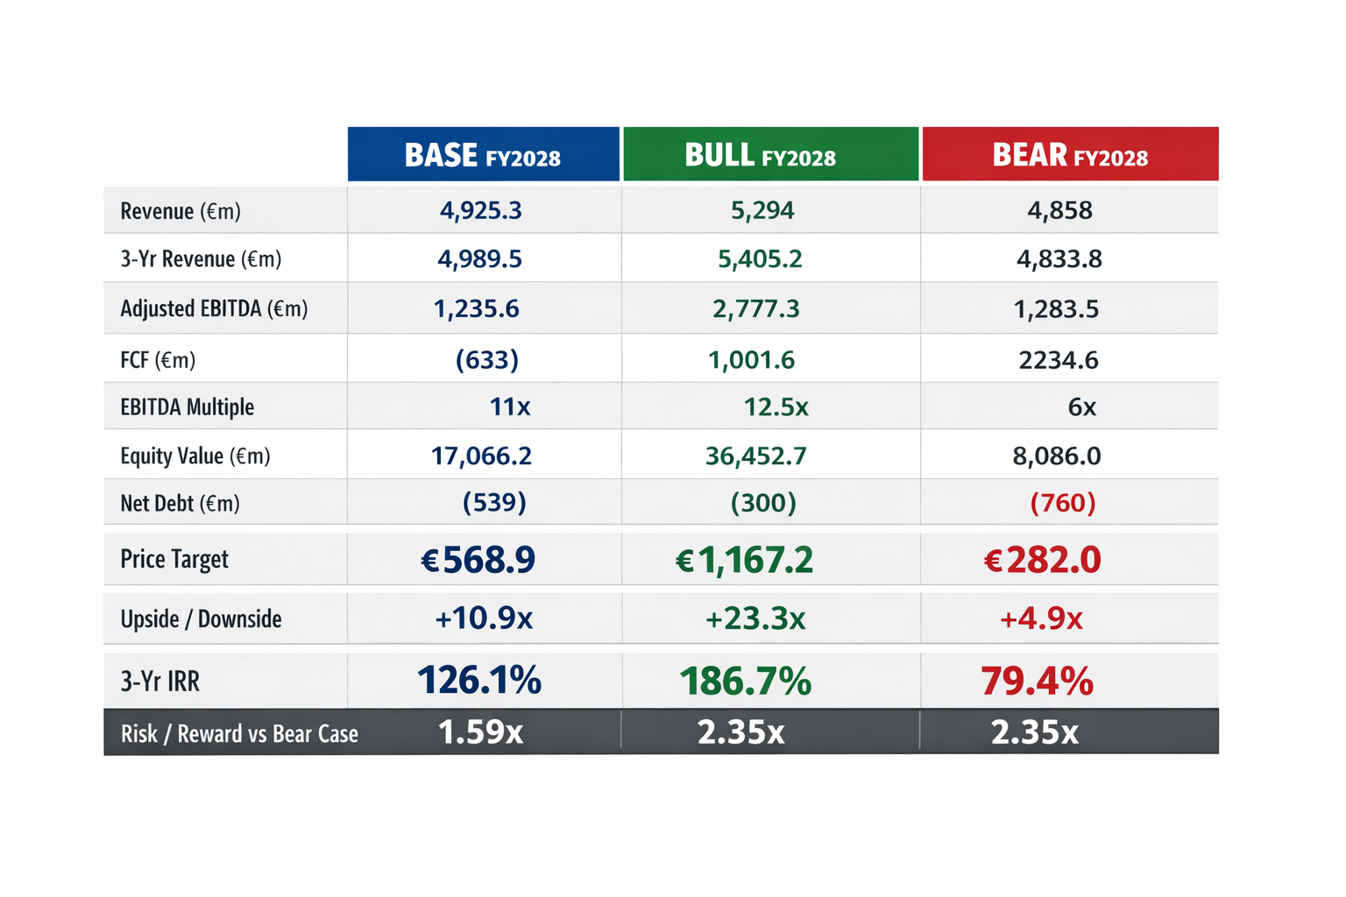
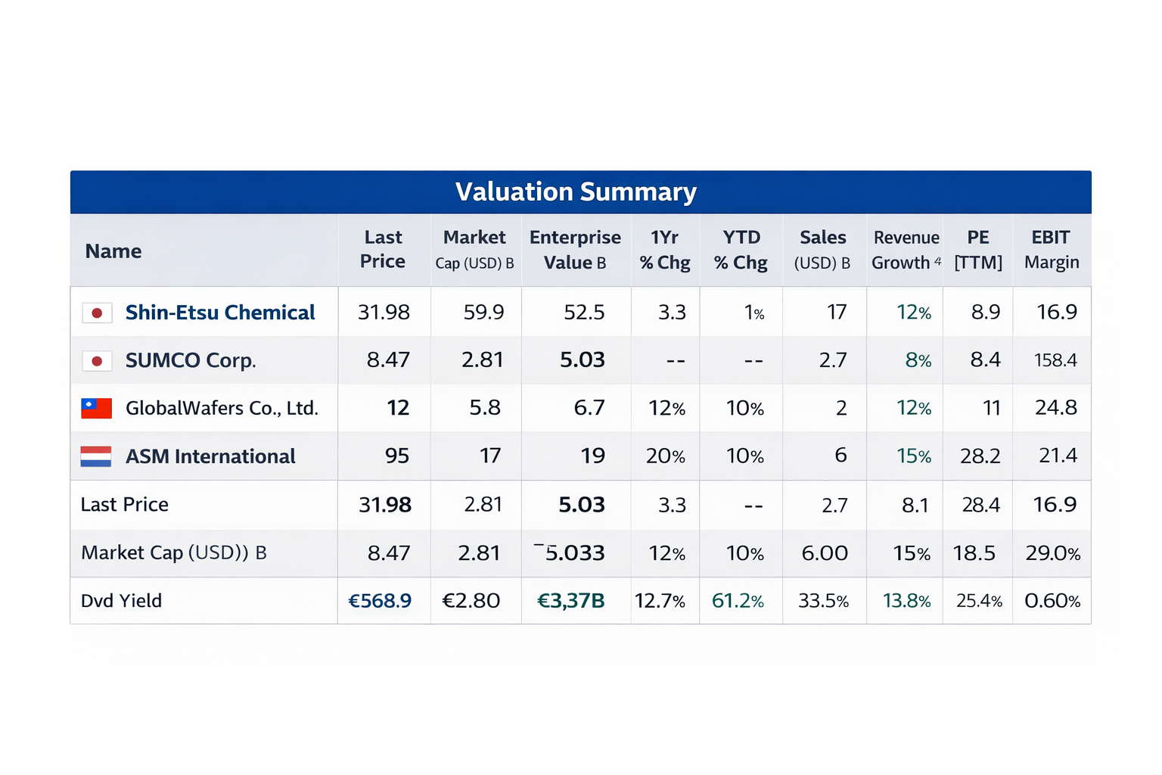
In the base case, Siltronic is valued on the assumption of a normalized wafer cycle recovery, with revenue reaching ~€4.9bn by FY2028, implying a ~4% three-year CAGR. Adjusted EBITDA margins stabilize around the low-to-mid-teens as utilization improves and pricing normalizes, supported by disciplined industry capacity additions. Applying an 11.0x EBITDA multiple, in line with historical mid-cycle trading levels for high-quality wafer peers, yields an equity value of approximately €17.1bn and a price target of ~€569 per share, implying a strong upside from current levels and an attractive mid-30%+ IRR over three years.
Bull Case Valuation
The bull case reflects a structurally tighter wafer supply environment, stronger-than-expected demand for advanced logic and memory, and sustained pricing power driven by 300mm wafer mix and long-term contracts. Revenue grows at a ~6.5% CAGR to ~€5.3bn by FY2028, while adjusted EBITDA margins expand materially on higher utilization and operating leverage. Using a 12.5x EBITDA multiple, consistent with peak-cycle valuations and high-quality semiconductor infrastructure assets, equity value increases to ~€36.5bn, corresponding to a price target of ~€1,167 per share and a triple-digit IRR, representing significant asymmetric upside in a favorable industry cycle.

Bear Case Valuation
The bear case assumes prolonged semiconductor cyclicality, weaker pricing, and delayed utilization recovery, resulting in flat to slightly declining revenue (~-1.5% CAGR) and compressed margins. Despite these pressures, Siltronic’s strong balance sheet and strategic asset base support continued positive free cash generation. Applying a conservative 6.0x EBITDA multiple, reflecting trough-cycle sentiment and reduced visibility, results in an equity value of approximately €8.1bn and a price target of ~€282 per share. While upside is more limited, the downside remains partially protected by net cash, long-term customer contracts, and replacement-cost support.
Risks:

1.Siltronic operates in a highly cyclical semiconductor industry, where wafer demand is driven by memory and logic spending cycles. Downturns in end-markets can quickly pressure utilization rates, pricing, and margins.

- The business requires sustained, large-scale capex to expand and maintain 300 mm wafer capacity, often years ahead of demand realization. Mis-timed investments or delays in ramp-up can materially depress free cash flow and returns.

- Siltronic relies on a small number of large foundry and IDM customers with strong bargaining power. Long-term contracts may limit near-term upside during upcycles while still exposing the company to pricing renegotiation risk in weaker markets.

